Skew Line

Definition
# Source: AI Source: Provided by: [Data Path: Persons Table -> ID Column: 1, Name_En Column: Motasem Essam] -> From: [ChatGPT] on [7/25/2026]
A Skew Line is a pair of lines in three-dimensional space that are not parallel and do not intersect.
In other words, two lines $l_{1}$and $l_{2}$are skew if:
$$\boxed{l_{1}∩l_{2}=∅}$$
and they are not parallel.
The essential characteristic of skew lines is that they do not lie in the same plane.
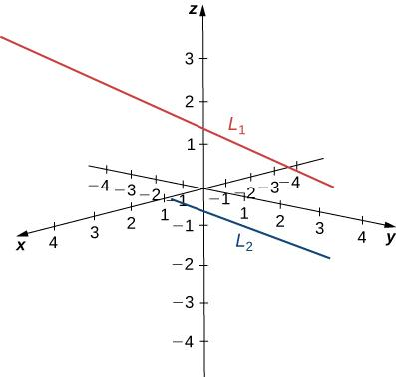
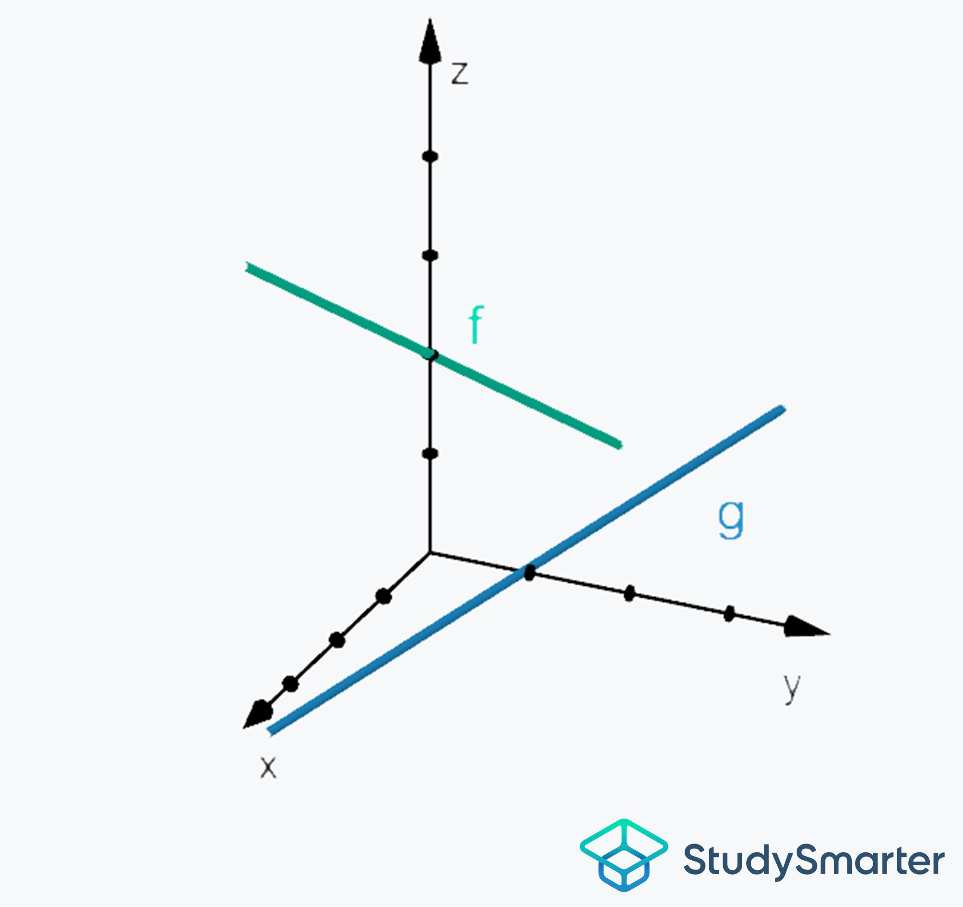
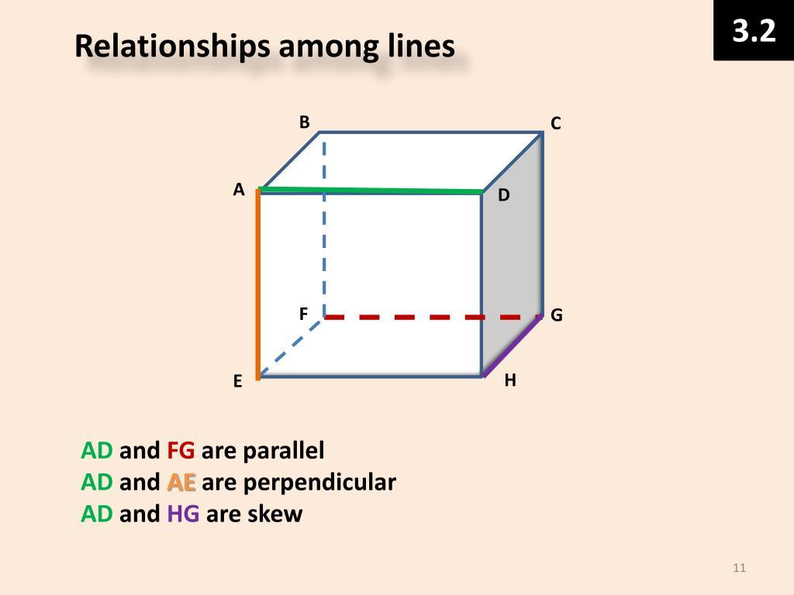
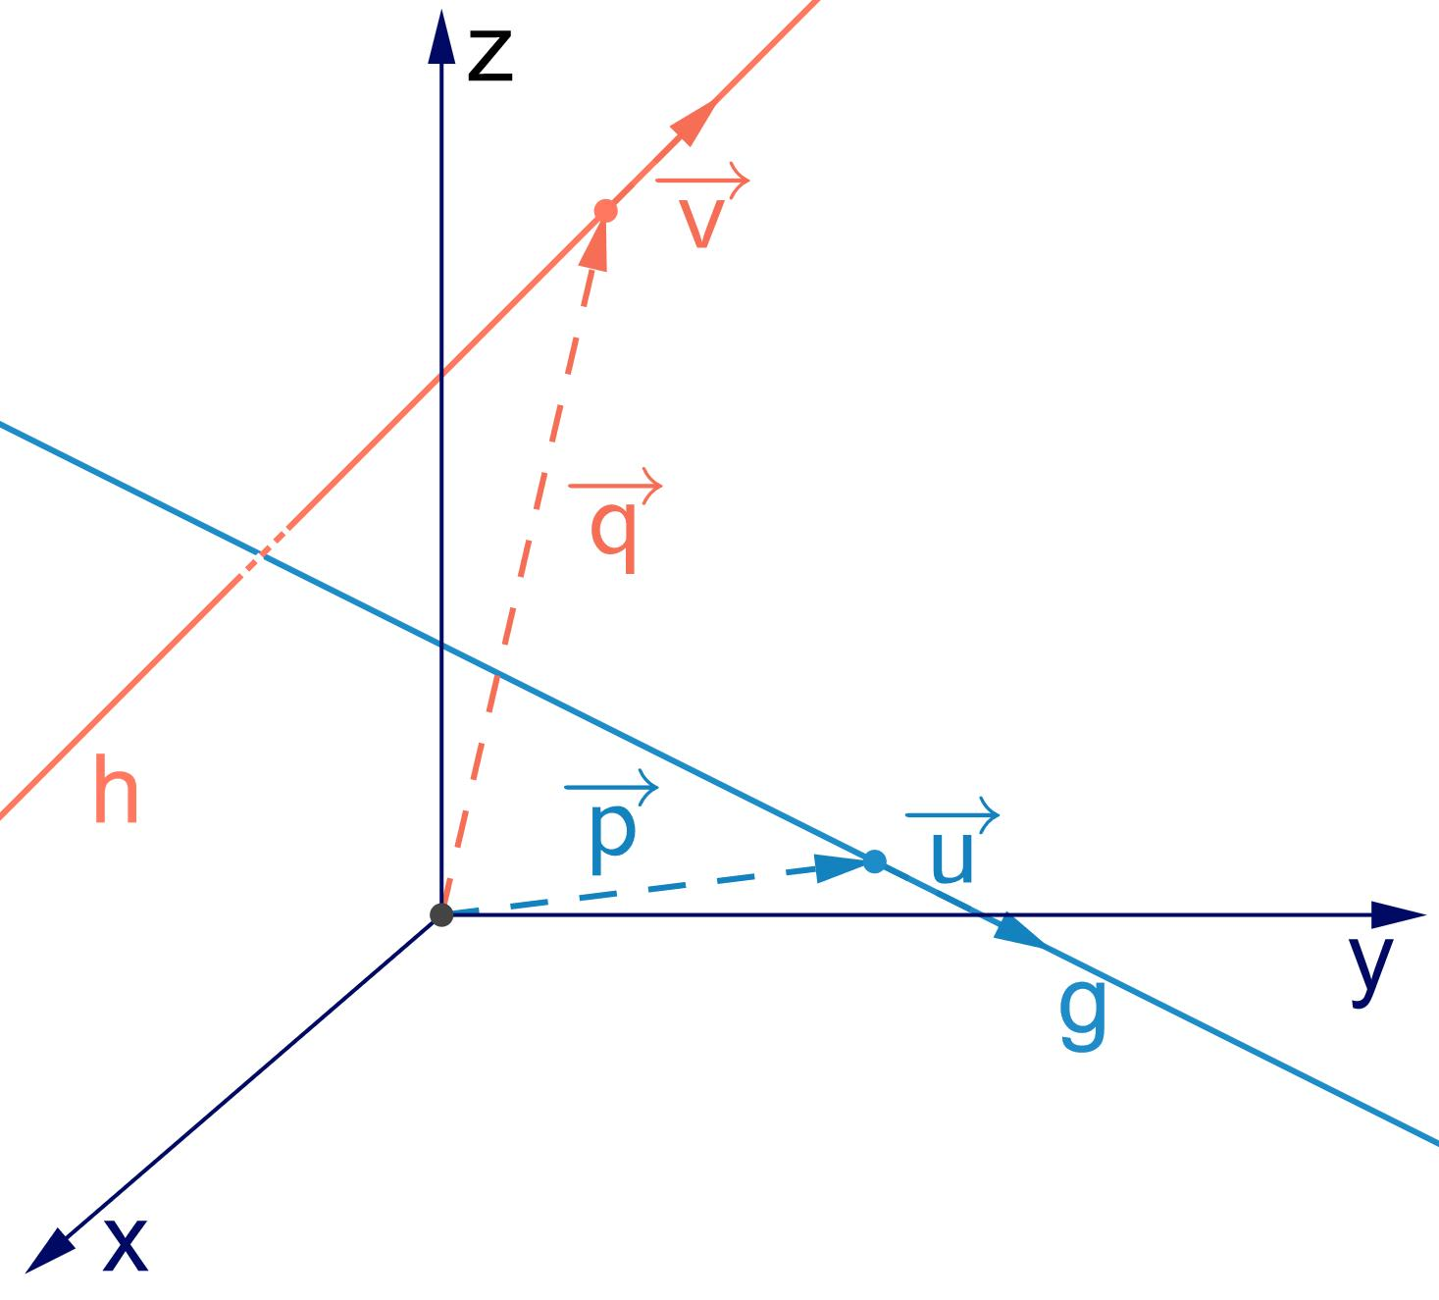
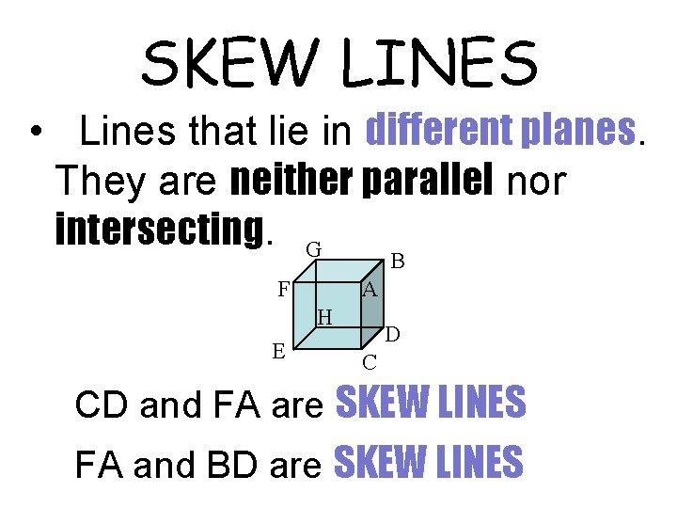

Purpose
# Source: AI Source: Provided by: [Data Path: Persons Table -> ID Column: 1, Name_En Column: Motasem Essam] -> From: [ChatGPT] on [7/25/2026]
The concept of Skew Lines is used to:
- Describe relationships between lines in three-dimensional space.
- Distinguish non-coplanar lines from parallel and intersecting lines.
- Analyze spatial geometry.
- Study lines in coordinate and vector geometry.
- Determine whether two lines can lie in the same plane.
- Calculate distances between non-intersecting lines.
- Support applications in architecture, engineering, CAD, and 3D modeling.

Fundamental Concept
# Source: AI Source: Provided by: [Data Path: Persons Table -> ID Column: 1, Name_En Column: Motasem Essam] -> From: [ChatGPT] on [7/25/2026]
In a plane, two distinct lines can only be:
- Intersecting.
- Parallel.
In three-dimensional space, there is an additional possibility:
- Skew.
Two skew lines are separated spatially so that they neither meet nor run in the same direction.
Conceptually:
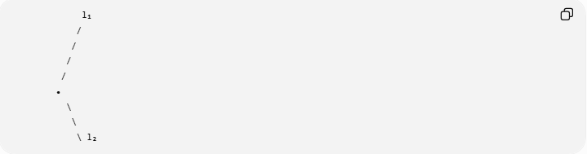
l₁
/
/
/
/
•
\
\
\ l₂
The important point is that this drawing is only a 2D representation. The two lines actually occupy different positions in 3D space and cannot be contained in one plane.

Fundamental Properties
# Source: AI Source: Provided by: [Data Path: Persons Table -> ID Column: 1, Name_En Column: Motasem Essam] -> From: [ChatGPT] on [7/25/2026]
Two lines are skew if all of the following are true:

1. They are in Three-Dimensional Space
# Source: AI Source: Provided by: [Data Path: Persons Table -> ID Column: 1, Name_En Column: Motasem Essam] -> From: [ChatGPT] on [7/25/2026]
Skew lines are a genuinely three-dimensional concept.

2. They Do Not Intersect
# Source: AI Source: Provided by: [Data Path: Persons Table -> ID Column: 1, Name_En Column: Motasem Essam] -> From: [ChatGPT] on [7/25/2026]
$$\boxed{l_{1}∩l_{2}=∅}$$

3. They Are Not Parallel
# Source: AI Source: Provided by: [Data Path: Persons Table -> ID Column: 1, Name_En Column: Motasem Essam] -> From: [ChatGPT] on [7/25/2026]
Their direction vectors are not scalar multiples of one another.

4. They Are Non-Coplanar
# Source: AI Source: Provided by: [Data Path: Persons Table -> ID Column: 1, Name_En Column: Motasem Essam] -> From: [ChatGPT] on [7/25/2026]
There is no single plane containing both lines.
Therefore:
$$\boxed{\text{Skew Lines}=\text{Non-intersecting}+\text{Non-parallel}+\text{Non-coplanar}}$$
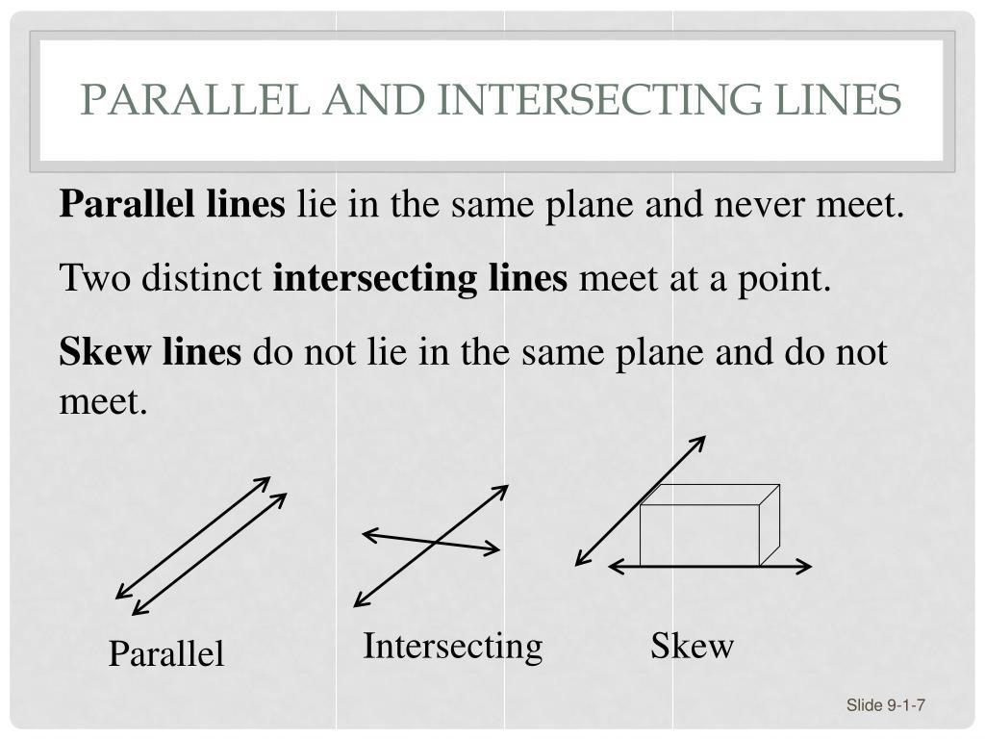
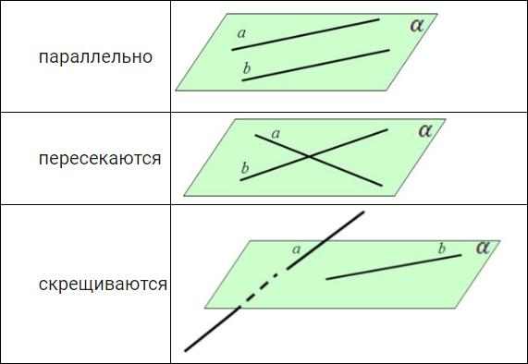
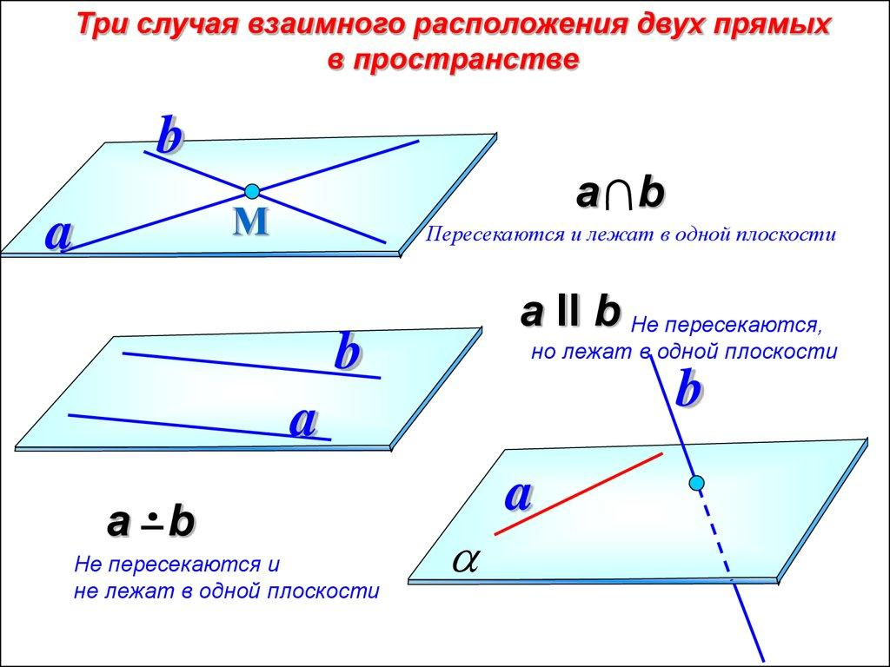

Mathematical Representation
# Source: AI Source: Provided by: [Data Path: Persons Table -> ID Column: 1, Name_En Column: Motasem Essam] -> From: [ChatGPT] on [7/25/2026]
Suppose two lines are represented parametrically as:
$$l_{1}:r=a+tu$$
and:
$$l_{2}:r=b+sv$$
where:
- $a,b$are points on the lines.
- $u,v$are direction vectors.
- $t,s∈R$.
For the lines to intersect, there must exist $t$and $s$such that:
$$a+tu=b+sv$$
If no such values exist and:
$$u∦v$$
then the lines are skew.

Example
# Source: AI Source: Provided by: [Data Path: Persons Table -> ID Column: 1, Name_En Column: Motasem Essam] -> From: [ChatGPT] on [7/25/2026]
Consider:
$$l_{1}:\left(x , y , z\right)=\left(0 , 0 , 0\right)+t\left(1 , 0 , 0\right)$$
and:
$$l_{2}:\left(x , y , z\right)=\left(0 , 1 , 1\right)+s\left(0 , 1 , 0\right)$$
The first line is:
$$l_{1}:\left(x , y , z\right)=\left(t , 0 , 0\right)$$
The second line is:
$$l_{2}:\left(x , y , z\right)=\left(0 , 1 , +s1\right)$$
Their direction vectors are:
$$u=\left(1 , 0 , 0\right)$$
and:
$$v=\left(0 , 1 , 0\right)$$
These vectors are not parallel.
To intersect, we would need:
$$\left(t , 0 , 0\right)=\left(0 , 1 , +s1\right)$$
The $z$-coordinates would require:
$$0=1$$
which is impossible.
Therefore:
$$l_{1}∩l_{2}=∅$$
and the lines are not parallel.
Thus:
$$\boxed{l_{1}\text{ and }l_{2}\text{ are skew lines}}$$

How to Determine Whether Two Lines Are Skew
# Source: AI Source: Provided by: [Data Path: Persons Table -> ID Column: 1, Name_En Column: Motasem Essam] -> From: [ChatGPT] on [7/25/2026]
Given:
$$l_{1}:r=a+tu$$
and:
$$l_{2}:r=b+sv$$
use the following procedure.
Step 1: Compare Direction Vectors
Check whether:
$$u×v=0$$
If so, the lines are parallel or coincident.
If:
$$u×v≠0$$
the lines are not parallel.
Step 2: Test for Intersection
Solve:
$$a+tu=b+sv$$
If a solution exists, the lines intersect.
If there is no solution, the lines are skew.
Step 3: Check Coplanarity
An alternative direct test is:
$$\boxed{\left(b-a\right)⋅\left(u×v\right)≠0}$$
If this scalar triple product is nonzero, the two lines are non-coplanar, and therefore they are skew.

Skew Lines vs Parallel Lines
# Source: AI Source: Provided by: [Data Path: Persons Table -> ID Column: 1, Name_En Column: Motasem Essam] -> From: [ChatGPT] on [7/25/2026]
Both types of lines do not intersect, but they differ in their spatial relationship.
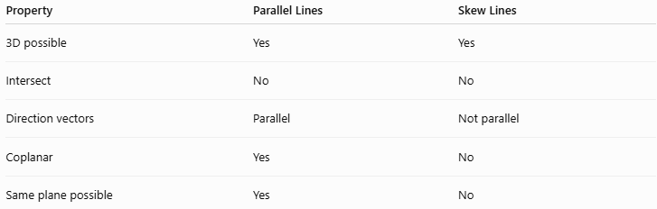
Property | Parallel Lines | Skew Lines
3D possible | Yes | Yes
Intersect | No | No
Direction vectors | Parallel | Not parallel
Coplanar | Yes | No
Same plane possible | Yes | No
Thus:
$$\boxed{\text{Parallel}⇒\text{Coplanar}}$$
but:
$$\boxed{\text{Skew}⇒\text{Non-coplanar}}$$

Skew Lines vs Intersecting Lines
# Source: AI Source: Provided by: [Data Path: Persons Table -> ID Column: 1, Name_En Column: Motasem Essam] -> From: [ChatGPT] on [7/25/2026]
Intersecting lines share a common point:
$$\boxed{l_{1}∩l_{2}=\left\{P\right\}}$$
Skew lines have no common point:
$$\boxed{l_{1}∩l_{2}=∅}$$
Furthermore, intersecting lines are necessarily coplanar, while skew lines are not.

Skew Lines vs Coincident Lines
# Source: AI Source: Provided by: [Data Path: Persons Table -> ID Column: 1, Name_En Column: Motasem Essam] -> From: [ChatGPT] on [7/25/2026]
Coincident lines are actually the same line:
$$\boxed{l_{1}=l_{2}}$$
Therefore, they have infinitely many common points.
Skew lines have:
$$\boxed{l_{1}∩l_{2}=∅}$$
and are not the same line.

Distance Between Skew Lines
# Source: AI Source: Provided by: [Data Path: Persons Table -> ID Column: 1, Name_En Column: Motasem Essam] -> From: [ChatGPT] on [7/25/2026]
Unlike intersecting lines, skew lines have a positive minimum distance.
For:
$$l_{1}:r=a+tu$$
and:
$$l_{2}:r=b+sv$$
the distance between skew lines is:
$$\boxed{d=\frac{∣\left(b-a\right)⋅\left(u×v\right)∣}{∣u×v∣}}$$
This distance is measured along a direction perpendicular to both lines.
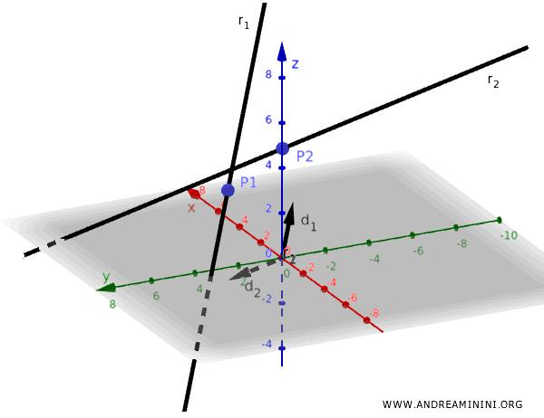
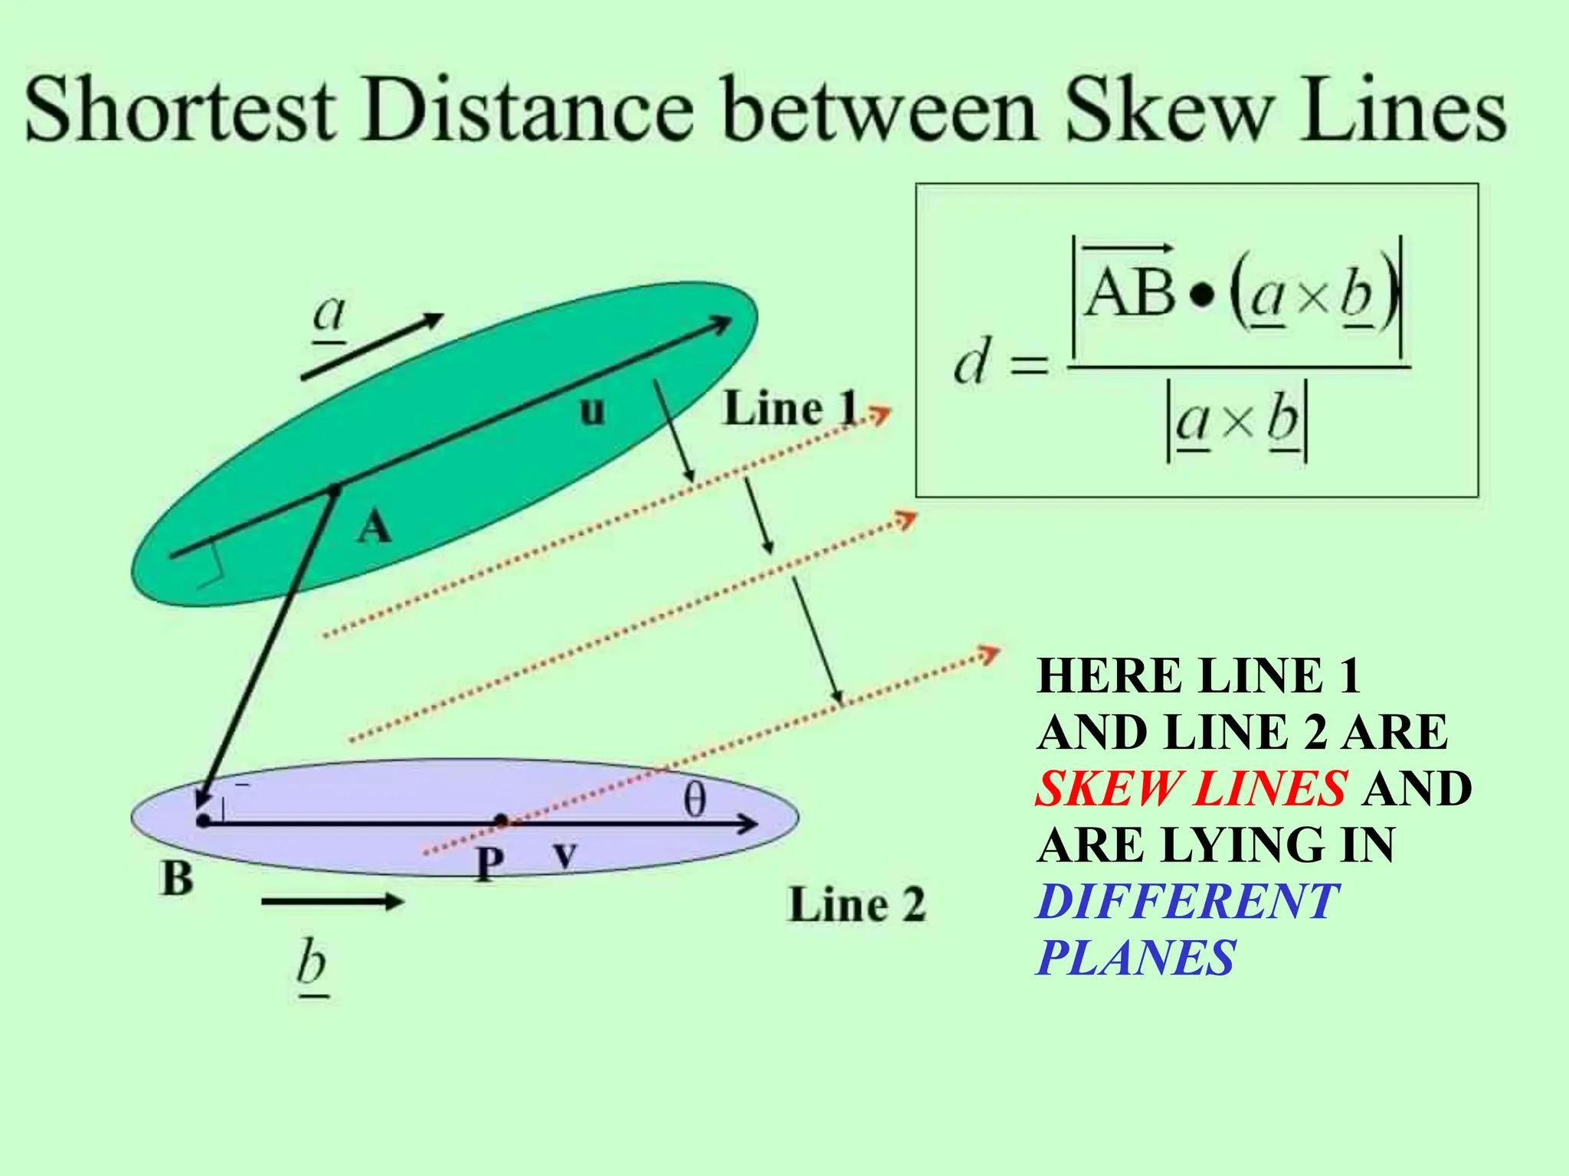
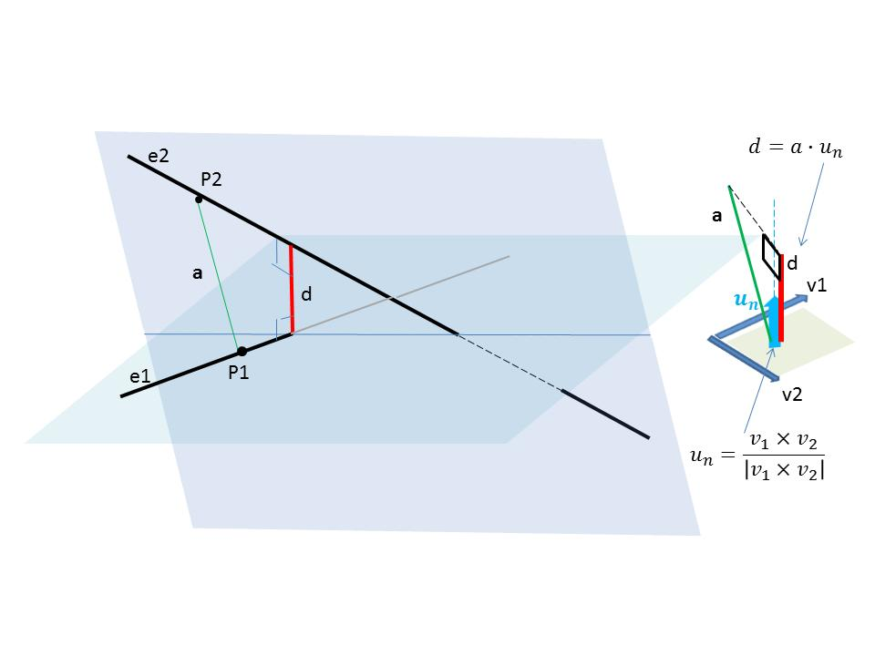
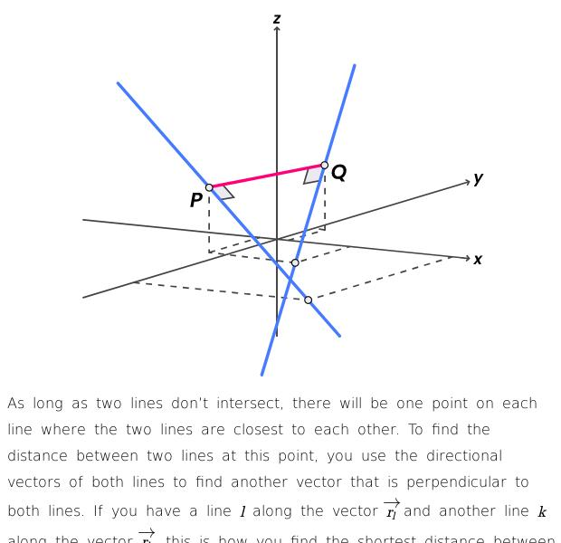
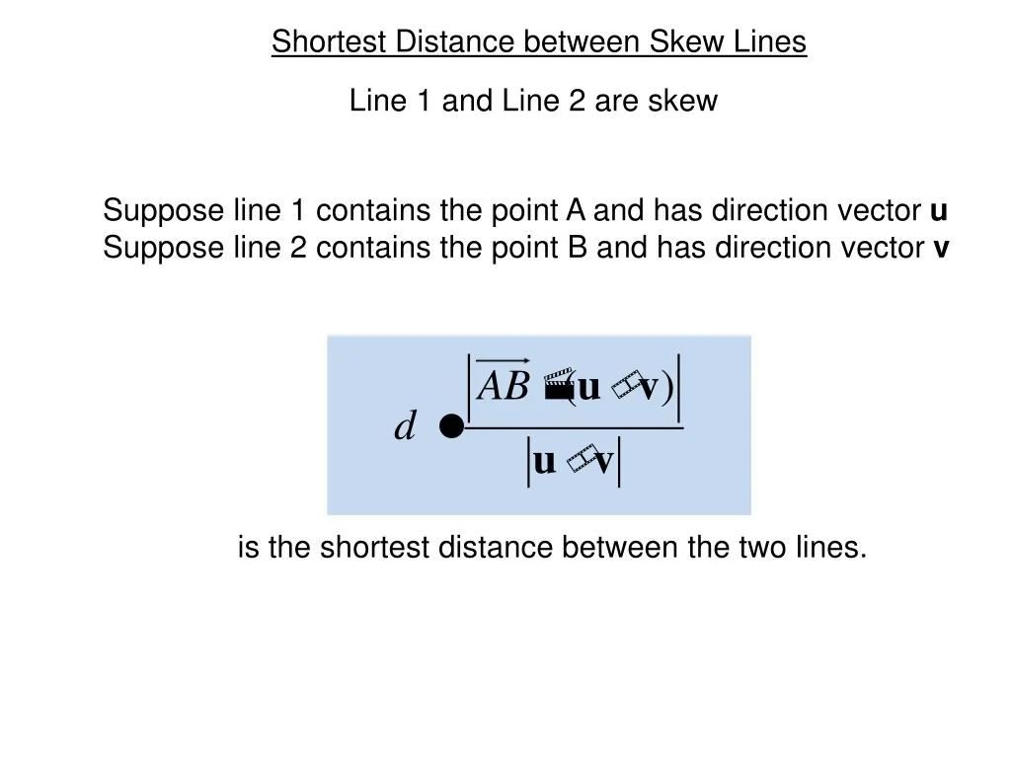
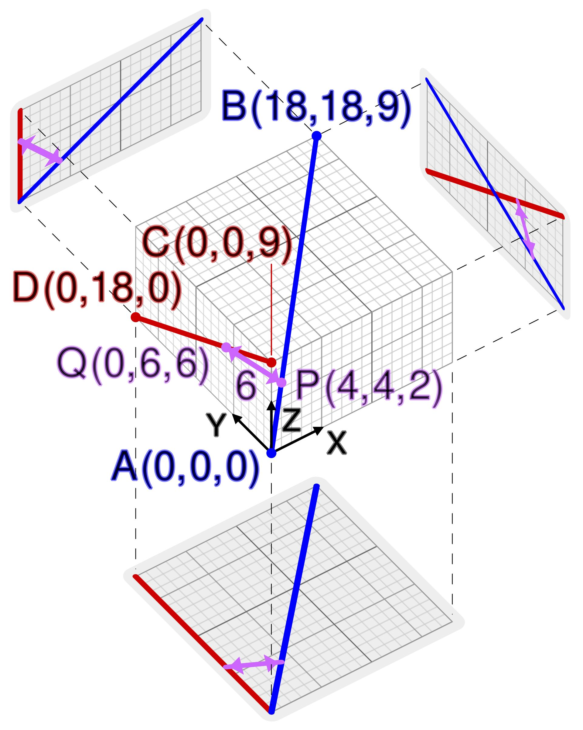

Common Perpendicular
# Source: AI Source: Provided by: [Data Path: Persons Table -> ID Column: 1, Name_En Column: Motasem Essam] -> From: [ChatGPT] on [7/25/2026]
For two skew lines, there is a line segment that is perpendicular to both lines and has the minimum possible distance between them.
This is called a common perpendicular.
If $d$is the distance between the skew lines, then:
$$\boxed{d>0}$$
Unlike intersecting lines, whose minimum distance is:
$$d=0$$

Example in a Cube
# Source: AI Source: Provided by: [Data Path: Persons Table -> ID Column: 1, Name_En Column: Motasem Essam] -> From: [ChatGPT] on [7/25/2026]
A common geometric example occurs in a rectangular prism.
Consider two edges that:
- Do not meet.
- Are not parallel.
- Lie on different faces.
Such edges can form a pair of skew lines.
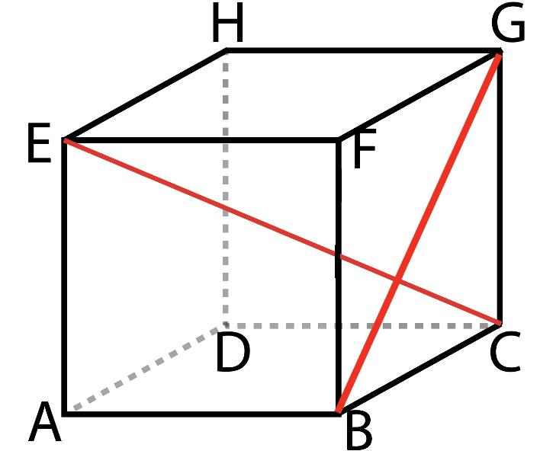
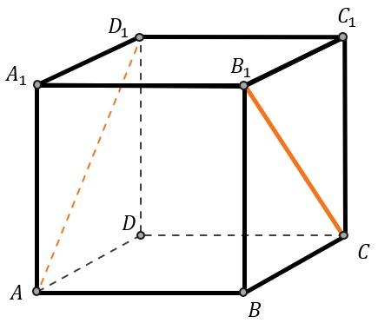
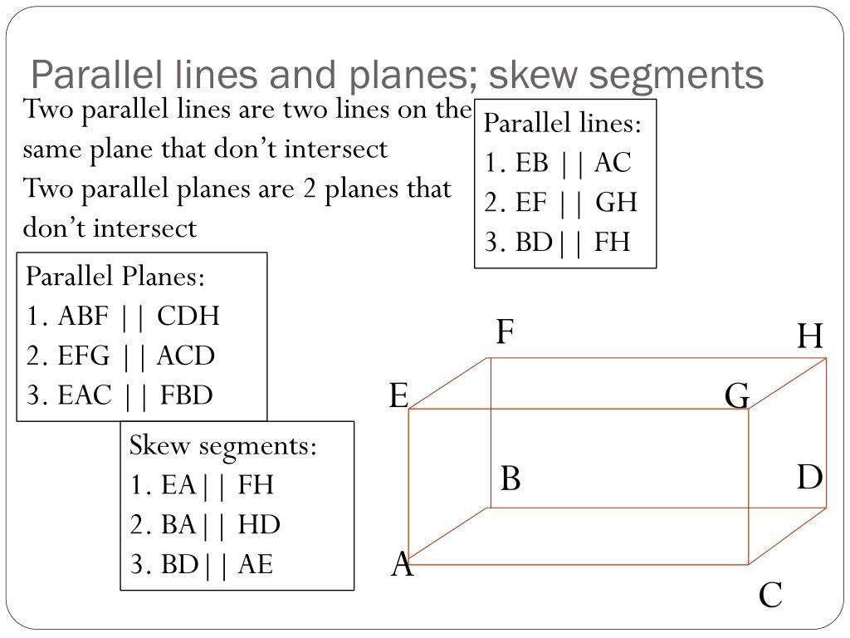
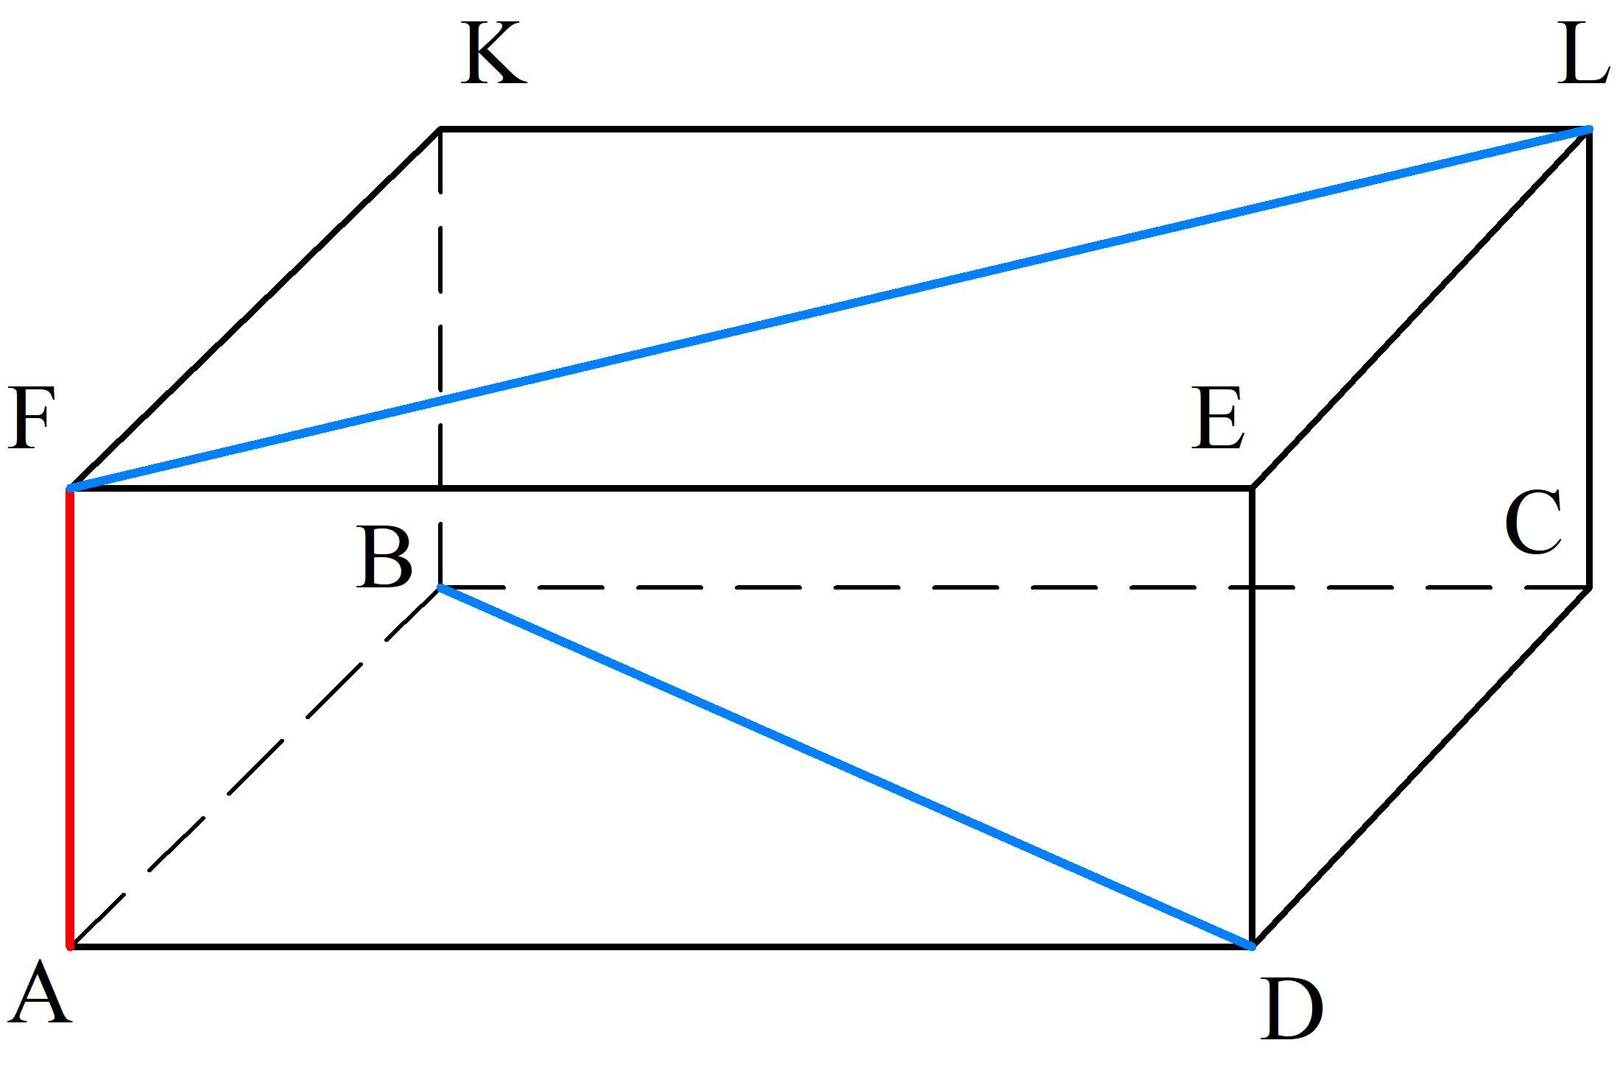
For example, one vertical edge and a horizontal edge on the opposite side of a cube can be skew.

Coplanarity
# Source: AI Source: Provided by: [Data Path: Persons Table -> ID Column: 1, Name_En Column: Motasem Essam] -> From: [ChatGPT] on [7/25/2026]
The defining geometric characteristic of skew lines is their non-coplanarity.
Two lines are coplanar if there exists a plane containing both of them.
For skew lines:
$$\boxed{∄Π: l_{1}⊂Π\text{ and }l_{2}⊂Π}$$
Therefore, no single plane contains both skew lines.
This distinguishes them fundamentally from parallel and intersecting lines.

Relationship with Planes
# Source: AI Source: Provided by: [Data Path: Persons Table -> ID Column: 1, Name_En Column: Motasem Essam] -> From: [ChatGPT] on [7/25/2026]
A line can be contained in a plane:
$$l_{1}⊂Π$$
Another line may lie outside that plane:
$$l_{2}⊄Π$$
If $l_{2}$is also non-parallel to $l_{1}$and does not intersect it, the two lines are skew.
Thus, skewness is fundamentally a 3D positional relationship.

Real-World Applications
# Source: AI Source: Provided by: [Data Path: Persons Table -> ID Column: 1, Name_En Column: Motasem Essam] -> From: [ChatGPT] on [7/25/2026]
Architecture
Structural members that occupy different spatial orientations can form skew relationships.
Engineering
Mechanical components may contain axes or edges that are skew.
CAD
Skew lines are important when modeling 3D objects and determining spatial relationships.
Robotics
Robot arms and joints may contain axes that are non-coplanar.
Computer Graphics
3D rendering systems use spatial line relationships for geometry and visibility calculations.
Construction
Different beams, pipes, or structural members may follow skew paths through space.

Key Points
# Source: AI Source: Provided by: [Data Path: Persons Table -> ID Column: 1, Name_En Column: Motasem Essam] -> From: [ChatGPT] on [7/25/2026]
- A Skew Line is one of a pair of lines in 3D space that are:
  - non-intersecting,
  - non-parallel,
  - and non-coplanar.
- Skew lines cannot exist as distinct lines in a purely two-dimensional plane.
- Their intersection is empty:
$$\boxed{l_{1}∩l_{2}=∅}$$
- Their direction vectors are not parallel:
$$\boxed{u×v≠0}$$
- They cannot be contained in the same plane.
- They have a positive minimum distance.
- A common perpendicular gives their shortest distance.
- Skew lines are fundamentally different from parallel lines because parallel lines are coplanar, while skew lines are non-coplanar.

Conclusion
# Source: AI Source: Provided by: [Data Path: Persons Table -> ID Column: 1, Name_En Column: Motasem Essam] -> From: [ChatGPT] on [7/25/2026]
A Skew Line is a three-dimensional positional relationship between two lines that neither intersect nor run parallel and cannot lie in the same plane.
The defining condition is:
$$\boxed{\text{Skew}=\text{Non-intersecting}+\text{Non-parallel}+\text{Non-coplanar}}$$
Skew lines are therefore one of the fundamental ways in which two lines can be positioned relative to each other in three-dimensional geometry.

